

Assignment 1:

*Videotaped Cooperative Interface*

*Evaluation of autotrader.ca*



Prepared For:  
Professor Fadi Malek

SEG3125 Spring/Summer 2018  
Due: Wednesday, May 30th, 2018.

Prepared By:

Mahyar Gorji (8135109)

Nicolas Paré (7084451)

Parastoo Saharkhiz (8697886)

# Table of Contents

**Table of Contents** **1**

**Summary of the Evaluation Procedures** **3**

**Information about interviewees** **3**

**Pseudo Code of the Steps Performed by User 1, followed by user comments:** **4**

Create account: 4

End results: 4

Users’ comments and interaction: 4

Post an ad: 6

End Result: 6

Users’ comments and interaction: 6

Final questions about overall experience for user 1: 7

**Pseudo Code of the Steps Performed by User 2, followed by user comments:** **9**

Quick Sign in 9

End Result: 9

Users’ comments and interaction: 9

Search by Payment 9

End Result: 10

Users’ comments and interaction: 10

Payment Calculator 10

End result: 10

Users’ comments and interaction: 11

Message a seller 11

End Result: 11

Users’ comments and interaction: 11

Final questions about overall experience: 12

**Malfunctions List** **14**

Four Most Significant Malfunctions 15

1. New user sign in error. 15

2. Login area not highlighted to the user 16

3. Significant Styling Issue: 17

4. Miscounting the Search Results: 18

**Proposal:** **19**

**Appendix List:** **20**

Figure 1: non-expandable message field 20

Figure 2: sign in error 20

**User Consent Forms** **21**

# 

# Summary of the Evaluation Procedures

Our group chose a website called AutoTrader to perform a videotaped user interface evaluation and examine its usability and user friendliness. AutoTrader is a car dealership website that allows users to search for vehicles, contact sellers, post their own advertisement, etcetera. Prior to selecting our candidates, we examined the website ourselves to find any components of the website that do not function as expected.

Two candidates were asked to traverse the website, undergoing a set of linear instructions designed to provide near full coverage of its features. In doing so, they encountered the same malfunctions and error codes we did, without prior knowledge of their existence.

The evaluation was done at the University of Ottawa, Building Learning Crossroads (CRX), room C521. The two interviewees were not introduced to the subject of this study prior to the interview and when announced, neither of them were familiar with this website, so it gave them a good chance to express their first impression of the website which gave us a more accurate result.

# Information about interviewees

The first user we interviewed was Erin Paul, a student majoring in biopharmaceutical sciences. Erin has good knowledge of the internet and navigating websites through her phone and personal computer, but as mentioned above, was not familiar with autotrader and its user interface.

The second user we had interviewed was Tae Kim, a third-year computer engineering student. We had a generic profile of an average user’s views of the site, also resulting in a few defects being found. We assumed that, due to his extensive background in technology and development, Tae might not experience the same complications with the website as Erin had, and might experience an easier time with navigation.

# Pseudo Code of the Steps Performed by User 1, followed by user comments:

## Create account:

* 1. Go to<http://www.autotrader.ca/>
  2. Click on “Sign In” button on top right (Note: Ensure your browser is full screen if you don’t see it)
  3. Click “Register with Email” button
  4. Add information and click register
  5. Go to email and confirm the registration by clicking “Click to Activate your Account”
  6. Login with the account credentials you created
  7. Procedure complete

### End results:

After clicking on the activate account link in the email, you will be redirected to the AutoTrader main page and you will need to sign in again with your credentials. The log in procedure must be done successfully and the user must see a “My Garage” option in the top right of the main page.

### Users’ comments and interaction:

After Erin created an account and clicked on the verification link emailed to her, she was redirected to the main page of the website and encountered an error message saying “Oops… Something went wrong. Hang on tight, our team is in full pursuit”.

Receiving an error message shortly after someone signs up to a website does not portray a pleasant image of a popular website. The user refreshed the page and was able to continue using the website as a registered user. This brings the question of why the error message was displayed in the first place.

The user was not pleased with this experience.

1. **Searching an ad**
   1. Select the “Any make” dropdown menu, and choose BMW
   2. From the “Any Model” drop down, select “Series 1”
   3. From the “Max Price” drop down, select “100,000”
   4. Enter your Postal code (or enter “K1N 6N5”)
   5. Press “search”
   6. Select “Sort” above the first listing, and choose “Year: New to Old”
   7. Click on an ad from a dealer
   8. Near the center of the screen click on the photo of the vehicle
   9. On the right hand side of the phot press the arrow
   10. Keep pressing the arrow to navigate through pictures/videos (Max 10)
   11. Press the “X” on the pop up to close the gallery
   12. How many km are in the car?
   13. Scroll until you see the “Payment Calculator” near the left side
   14. Under the “Payment Calculator” button Select the “Save” button
   15. Save the ad to Garage
   16. Choose Add to compare by clicking the button on the right of “Save”
   17. Find another car and Add to compare by following the same step as above
   18. Go to My Garage -> Saved searched
   19. Click on “Compare Vehicles”
   20. Procedure complete

**End result:**

You will be able to see detailed data on each vehicle you have added to your compare list, such as mileage, carproof availability, a link back to the vehicle, etcetera. The option is useful for indecisive buyers who need to compare their findings.

**Users’ comments and interaction:**

The user did not seem particularly pleased or displeased with a feature we thought was very useful in nature. We hypothesized later that the compare function was functional, but not as aesthetically appealing to the day-to-day user, and was therefore not memorable.

## Post an ad:

* 1. Click on “Sell My Car” from the top
  2. Select “post your ad now”
  3. Add photos, input the asked information
  4. Click “Next”
  5. You will be redirected to a new page
  6. Select the “Basic listing”
  7. Scroll down to “Sell for more with a vehicle history report”
  8. Click “No, thanks. Just Post My Ad”
  9. Check your email to see a link to you ad

### End Result:

A link to your ad will be emailed to you. You can edit/delete the ad. Your ad must show when searched with similar specifications.

### Users’ comments and interaction:

When our subject posted an ad, she received an email mentioning that the ad was not posted due to an unknown error. The email did not mention the exact reason the posting failed, so the user suspected maybe the picture attached was not of the right format. She attempted posting a second time with a different picture, however, another email with the same message was received that prevented her from posting an ad to the website.

This was a frustrating experience for the user, leading her to suggest giving more details of the specific reasoning involved with the ad posting failure, so a correction could be made. Also, before the completion of posting the ad, if an error was shown in the page via an asterisk, it could give the user a chance to correct a specific field that caused that error, resulting in the elimination of frustration and wasted time.

1. **Edit/ Delete add**
   1. Find your ad in “my garage”
   2. Try to Edit the ad
   3. Delete the ad
   4. Procedure complete

**End Result:**

These actions must be performed as expected, where you can edit any given field in your original advertisement, and also be able to remove it completely from autotrader.ca

**Users’ comments and interaction:**

Erin saw her advertisement in “my garage”, with all the edit/delete functionalities present. However, when Erin clicked “edit”, the following error message was received.

## Final questions about overall experience for user 1:

*- What did you think about the website overall?*

“I thought it was a little bit confusing to navigate but I think once you use it for couple minutes it becomes easier.”

*- What did you like about the website/UI?*

“I liked how easy it was to search for specific cars and how you could filter by price, or kilometers, etc.

*- What did you dislike about the website/UI?*

“I disliked how difficult it seems to post an ad. Also there are a lot of stuff on the page so it is kind of hard to see specific things.”

*- If a friend was looking for a car, would you recommend AutoTrader?*

“Maybe as a point to star but I wouldn’t necessarily say for sure use autoTrader.”

*- Would you recommend a different car sales site based off your experiences?*

“Yes.”

*- How did you about feel about this procedure?*

“Felt fine.”

*- Did you at any point during this procedure feel frustrated at all, and at what point?*

“When the ad wouldn’t post was a bit frustrating.”

*- As a user, how can auto trader’s UI be improved? What would you like to see incorporated?*

“I think the main features like posting an ad or looking for a car could be separated from other parts of the website so it’s more obvious that that’s exactly what you want to do you can just go in and find what you need instead of having to look around.”

# Pseudo Code of the Steps Performed by User 2, followed by user comments:

## Quick Sign in

* 1. Click on the “Sign In”
  2. When the pop up appears, click on “Google” on the Quick Sign In section on the left
  3. “Choose an account” or “Sign in”

### End Result:

The user will be signed in the website and be directed to the homepage where a “My Garage” dropdown menu is now available.

### Users’ comments and interaction:

The user tried to sign in through his gmail account, but faces issues while switching between gmail accounts (It was not allowing him to change accounts). He tried signing in with Facebook and signed in with no issue. The “Quick sign in” took longer than expected due to the issues faced when attempting to switch between gmail accounts, which the user was not pleased with.

## Search by Payment

* 1. In the search field choose the “Search by Payment” tab
  2. In the Min. Payment area put “$100”
  3. In the Max. Payment put “$900”
  4. Monthly payment: “Longest Available”
  5. Postal Code: “K1N 6N5”
  6. Click search
  7. From the results, click on the “2017 Mercedes Benz C300 4Matic”
  8. In the “Inquire about this Vehicle” box, click “Click to Show” to view the dealer’s phone number
  9. What is the mileage on the car?
  10. Is a CarProof available?

### End Result:

The user must be able to find vehicles that match the specifications in the search. The user must be able to view the seller’s phone number. The user must be able to find the information about the vehicle such as mileage and availability of CarProof with no issue.

### Users’ comments and interaction:

The user was able to navigate through the search result and find the wanted car. He was able to find the information regarding the car with no issue. However, he suggested the page is too crowded with information that it can be difficult to find the most important information that a buyer is looking for.

## Payment Calculator

* 1. Underneath gallery of the ad, click on the “Payment Calculator” button
  2. Select “36 mo @ 3.99%”
  3. Cash down: “5000”
  4. Trade In: “1000”
  5. Payment Frequency: Monthly
  6. Credit rating: Poor
  7. Click the checkbox “Include Sales Tax”
  8. Click “Check Availability”
  9. Enter your name, email (10 min. mail/ Fake email), and phone #. Enter a message for in the textbox for the inquiry
  10. Click on Submit - What do you think about the response received from the website?
  11. Exit the Payment Calculator by clicking the X
  12. Procedure complete

### End result:

They will receive an email from a representative to the email address they provided.

### Users’ comments and interaction:

The user was able to find the “Payment Calculator” button and was able to use it to calculate different method of payments and was able to message the seller to inquire about availability of the vehicle. When the user clicked the submit button, he received a message on the screen mentioning that he will be contacted by the representative. Unfortunately we were not able to wait for the seller to message us back during the interview, so we could not discover the messaging feature of the website to completion.

## Message a seller

* 1. Search for a car with following details:
  2. Make: Ferrari
  3. Max Price: 200,000
  4. Postal Code: K1N 6N5
  5. Click on “2018 Ferrari 275 - OTTAWA”
  6. On the right side of the page, in the “Inquire About this Vehicle” box, add your information
  7. Edit the Message
  8. Input the Verification code
  9. And click “Email Seller”
  10. Procedure complete

### End Result:

The message must be successfully sent and received by the seller. The seller may respond to the inquiry and the buyer should receive the message with a proper notification notifying the user.

### Users’ comments and interaction:

The user was able to find the message box on the page and was able to submit his inquiry about the vehicle to the seller. Unfortunately we were not able to wait for the seller to message us back during the interview.

## Final questions about overall experience:

*- What did you think about the website overall?*

“I think it had a lot of cool functions for sure but I find that if you weren’t guiding me through this then it would take me a little time to adjust to find things; I give it a total of 7/10. I’ve seen better websites, I’ve made better websites. I think it’s too cluttered, it’s too much. Needs to be organized better, because I don’t like the ‘Commercial/heavy trucks, Trailers, RVs, Boats’ on top of the page (referring to the heading of the website with different categories of vehicles to choose from). Maybe put it in a category of cars, category of equipment.”

*- What did you like about the website/UI?*

“I do like the fact that contacting the person is very easy, I think it’s very loose though, but that could be a good thing because I feel like most people won’t mess round with the inquiry stuff. but at the end it is very easy to contact them. I don’t know if this is a feature, for the Ferrari there is a contact information and in the other one there was a contact information to call them, I do like the fact that you could have that option.”

*- What did you dislike about the website/UI?*

*- If a friend was looking for a car, would you recommend AutoTrader?*

“No. But if they’re desperate, yeah!”

*- Would you recommend a different car sales site based off your experiences?*

“I don’t know a car website but I feel like you can do better. I’d say google it, and if this site is the first one that comes on google, then great. I would tell them to google it first because google optimizes your searches to most popular choice which usually you can assume it’s one of the best choices out there. So if this one comes up then sure. But from my experience it’s not good enough to recommend it and put my word on it.”

*- How did you about feel about this procedure?*

“It was an interesting experience.”

*- Did you at any point during this procedure feel frustrated at all, and at what point?*

“I’m not going to say I was frustrated, because I’ve seen some bad UI before, they exist out there. I’m used to it. I think that the UI world is not as great. This is very typical, every website nowadays has a format like this especially when it comes to sales. So I think this is just the norm, it’s not great, it’s not bad, but I personally don’t like these websites because I make my own websites and prefer them in a different way.”

*- As a user, how can autotrader’s UI be improved? What would you like to see incorporated?*

“

1. They need a better security clearance for when people post.

2. Please get rid of the categories on top, you can put it somewhere else, you have blank space between

“What’s My Car Worth” and “My Garage”.

3. Your home button didn’t seem to me like a home button at first I thought it was just a logo. Maybe you want to make it more obvious.

4. Also how can you have 4 out of 2 new in this Ferrari? 4 of 2? I only see one!”

# Malfunctions List

|  |  |
| --- | --- |
| 1. | Error message shown after the user signed up with email |
| 2. | The login area is not clearly highlighted to the user |
| 3. | The “Sign up” and “Login” functions were not separate. |
| 4. | When the account is activated, the user is expected to be signed in. It’s not the case. The user must sign in again after the account activation. |
| 5. | When the user signs in, there is a very little indication that shows he/she is logged in. The “My Garage” option is the only indication and not much obvious. |
| 6. | When creating an ad, there was no check being done before posting. (picture could be irrelevant to the website). Needs an admin to check the new posting before going to the website. |
| 7. | If an ad post experiences an issue, the email send to the user does not specify what the problem was. The website could warn the user of the fields causing the issue before proceeding with posting the ad. |
| 8. | While viewing the images/videos, when passing a video for the second time, it does not stop playing |
| 9. | When clicking on the photo, on the right there is a message written to send to sender. If expand the message field, the button goes out of reach. |
| 10. | When the page is loaded for the first time after logging in, a pop up appears to register. There is no need, the user is already registered. -> Cancel button does not close the pop up (Only clicking “x” exits) |
| 11. | Error in counting search results: 4/2 cars found! |

## 

## Four Most Significant Malfunctions

### 1. New user sign in error.

**Description of the malfunction:**

When activating your account with autotrader, the website, like many others, requires finalization through a link sent via email. When clicking on the provided link, the user is sent to autotrader, expecting a confirmation message regarding their account activation status, but are instead treated to the autotrader homepage, with no messages in sight. The user then has to click ‘sign in’, which may not be obvious, and when they attempt to sign in via email, they are treated to an error message. This error message does not persist after a page refresh, which makes the user question the error’s existence.

**Significant Questions Answered:**

1. How is the malfunction manifested?
   1. The user verifies their email and ends up landing on autotrader, where they have to manually log in again, only to see the error in figure 2.
2. At what stage is the interaction occurring?
   1. The interaction occurs at the goal-forming stage. The user has already begun to plan their next goal/plan of action with the website, but is greeted by an error that acts as an obstacle in their path.
3. At what level of the user interface is it occurring?
   1. This malfunction occurs at the presentation level of the user interface
4. Why is the malfunction occurring?
   1. The malfunction occurs likely due to a structural issue, where when new users are logged in, it redirects them to an error site instead of a privileged home page (ie. with new user options).

**Result of the malfunction:**

The user is surprised to see an error immediately after attempting logging in, as it is against the norm, but is even more surprised that refreshing the page shows that she was logged in already and that the error was placed incorrectly.

**Recommendations for changes:**

Revisit the code structure of the website that raises errors, and ask users to refresh the page, and to contact the support team if further issues ensue. This way, the user will not assume that the error is supposed to persist, and can understand that it was a random occurrence.

### 2. Error Message after posting an ad

**Description of the malfunction:**

If an ad post experiences an issue, autotrader will automatically send the user an email mentioning that the ad had an issue or was altogether declined. However, the email sent to the user is vague in nature and does not specify what the problem was, leaving users with a moment of suspense before opening their advertisement.

**Significant Questions Answered:**

1. How is the malfunction manifested?
   1. The malfunction is manifested when the user has to check their email to determine if there was an error in their posting, and is not given an explicit reason why.
2. At what stage is the interaction occurring?
   1. The interaction occurs at the action-execution stage. The user submits their advertisement and is then notified of an issue with the advertisement via email.
3. At what level of the user interface is it occurring?
   1. This malfunction occurs at the task level of the user interface.
4. Why is the malfunction occurring?
   1. The malfunction occurs because the website does not inform users of issues with any input fields of their advertisement before submission, and instead auto-emails the user a vague response notifying them of an issue.

**Result of the malfunction:**

The user is confused as to why their advertisement was declined, because there is no mention of the reasoning in the email sent. The user becomes slightly impatient, and frustrated that they have to travel all the way to autotrader to receive another vague message.

**Recommendations for changes:**

Have multiple categories for the automatic email to select from and place it in the header line. That way, users are primed for the knowledge of what the advertisement cancellation reason was, and can follow the link to autotrader for more information.

### 3. Significant Styling issue

**Description of the malfunction:**

When messaging a seller on autotrader, the box on the right-hand side is reserved for inputting your email and a small message to the seller, as well as a final ‘send’ button. The message box can be resized by dragging the bottom right corner, but this also displaces the ‘send’ button (Figure 1). If you displace the button beyond the window allocated for the message, and the resize corner is off screen as well, there is no way to recover it except for restarting your inquiry.

**Significant Questions Answered:**

1. How is the malfunction manifested?
   1. The malfunction is manifested when the user attempts to resize the inquiry box, and resizes it and the ‘send’ button beyond the screen.
2. At what stage is the interaction occurring?
   1. The interaction occurs at the action-execution stage. The user is in the process of writing an inquiry for the vehicle and could potentially resize the text box too far.
3. At what level of the user interface is it occurring?
   1. This malfunction occurs at the presentation level of the user interface.
4. Why is the malfunction occurring?
   1. The malfunction occurs because the website does not dynamically restructure where the submission and resize functions are, according to the inquiry box’s current size and location on the window.

**Result of the malfunction:**

The user is frustrated that they have potentially lost their progress in messaging a seller for a vehicle they are interested in, and would have to, best case scenario, copy paste their message and start from the beginning.

**Recommendations for changes:**

Have dynamically restructuring windows or create a message character limit for the inquiry, such that the submit and resize buttons do not go off-screen.

### 

### 4. Miscounting the Search Results

**Description of the malfunction:**

When searching for certain car makes, the search result counter may display invalid values for the number of vehicles that match the search criteria. In the actual video-taped evaluation, when user 2 searched for a ferrari, he was given the following line in his number of search results found: “search results: 4/2 cars found!” Obviously, you cannot have 4/2 cars be the result of your search.

**Significant Questions Answered:**

1. How is the malfunction manifested?
   1. The malfunction is manifested when the user attempts to search a vehicle by make.
2. At what stage is the interaction occurring?
   1. The interaction occurs at the goal-forming stage: the user wishes to begin searching through the results after filling out his search inquiry.
3. At what level of the user interface is it occurring?
   1. This malfunction occurs at the presentation level of the user interface.
4. Why is the malfunction occurring?
   1. The malfunction occurs because the website very likely had a mathematical error in its code structure when displaying search results.

**Result of the malfunction:**

The user may not have an accurate representation of how many vehicles meet his search criteria in his area, and would therefore have to be weary that he/she does not click on a ‘promoted’ vehicle that is out of his range.

**Recommendations for changes:**

Fix the arithmetic involved in displaying search results, and make the display font larger for buyers to notice quickly when searching.

# Proposal:

After we completed conducting the video-taped evaluations with our two users, it became apparent that there are certain changes that the company could implement to improve their user experience design.  
  
One of the key areas of opportunity was how Autotrader handled errors. It would be ideal if their system lacked errors as a whole; but they should focus on providing legible, and reasonable explanations as to “why” the error happened to the user. Following up, the detailed information regarding the error can be provided in a separate link.   
Another area of opportunity would be overall aesthetic design of the website. In many cases of our malfunctions, our users were confused, as they were unclear of how to perform the next step, or to visually see verification of the completeness of the current procedure. Autotrader should focus on cleaner website organization to improve visibility of user options.

Lastly, Autotrader should continue to receive feedback from their audience to fix and prevent future errors, such as the arithmetic error received when user two viewed the Ferrari make filter. Doing so would show better organizational capabilities, plus a responsibility to users and shareholders alike, which will attract user traffic.

# Appendix List:

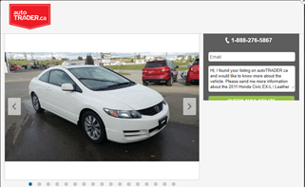

## Figure 1: non-expandable message field

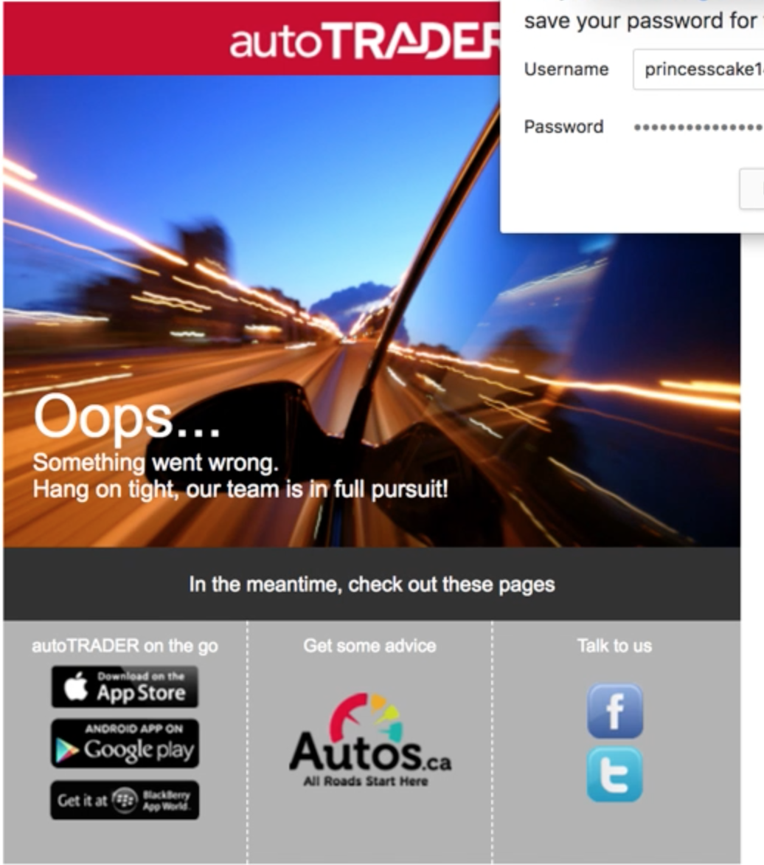

## Figure 2: sign in error

# User Consent Forms

